**Introduction**

We are trying to build an application that helps our users to order food online without searching for restaurants specifically. In our web application our user will find various types of food of different restaurant, which are delivered by online order. This web application will help peoples to save their time in their busy time and it will make peoples easier to order from online and grab their desired food from home. In this application people can ask for any important information to the admin. People can place their valuable review to our application it also stores in our review page and also visible to our new and continuous users. It will be very helpful to our society to live with comfort and utilize their time by saving time through ordering by online in our web application.

# **Motivations:**

* The main motive behind this project is to help people who are having difficulties with their order.
* Our application helps the users to find food without wasting a lot of time finding restaurants separately.
* Many people seem confused when ordering food online from restaurants because they have no idea where they will get the tastiest food based on reviews.
* This application will suggest the user’s best restaurants based on their food choice.

# **Challenges:**

* Implementing certain features such as dynamically updating the news feed page for each of the posts.
* Since this project is entirely team driven, we lack any client or upper management feedback. Lacking well-defined client-requirements will make the development process a little more difficult.
* Learning new things and implementing them was one of the hardest challenges. As a team learning new technologies that we haven't worked with before.
* It will be challenging for us to develop this application from scratch without any prior knowledge of web-based application development.
* Ensuring strict user security and protecting the user’s data

**Functional Requirement:**

* **User authentication:** Since our site deals with information about the user’s and their email, password etc. All authentication procedures should be followed. Our team aims to use strict authorizations of the user login and registration process and ensure industry-level quality.

**Scenario:** When a user tries to access their account or homepage/profile page while they are not logged in, they would be redirected to the login page. Once the user enters their username and password and if the authentication is successful, they will be redirected to their news feed page. If anyone not signed up yet then they will make sure that their signed up perfectly with all information then able to log in with their username and password. We will have the same procedures for company login / registration also. Pages with sensitive/personal information can only be accessed through logging in to the system.

**There will be 2 types of users:**

* Admin
* Users

**Admin:** Administrator of the system.

**Input:**

* Name
* Email
* Password.

**Output:**

* User authentication
* Admin panel
* Access to administrative functions
* Logout
* **Users:** The Users of our system are the most important part of the site. Who are looking for information, notices, buy and many more?

**Input:**

* Username
* Password.

**Output:**

* User authentication
* Access to user homepage & profile
* logout. want they can hide.

# **User Profile:** User profile will contain their name, their profile image.

* Data must be entered by the admin before a request can be approved.
* All types of users will have user profiles that will contain their information
* There will be a conversation section for discussion between customers and admin.

# **Non-Functional Requirement:**

* Privacy of all users shall be maintained.
* Latency of loading time and searching time should be fairly low.
* The application should be easy to use and optimized for all browsers.
* In addition to our target audience, we also want our site to appeal to any generation. An user-friendly and intuitive user interface is to be developed with this goal in mind.
* The goal is to ensure the highest level of compatibility by making the application platform-independent. So, that it is easily accessible to all.
* The application will be user-friendly.
* User interface should be appealing.

# **Technologies:**

* Programming Language - Python.
* Database - Django.
* IDE – Visual Studio Code

# **Scenarios:**

* **Browse through home page:** Users can browse through home pages which are posted by different restaurant’s site. Users can also search other food item, posts of other users as they posted their review.
* **News feed:** Users will have their own news feed where they can see what type of foods are posted for available orders. This feed may differ for different users.
* **Emergency:** In case of emergency users can contact admins and there is also an emergency page where users can find a text box which directly contact with admin through mail.

**Use Case Scenarios:**

|  |  |
| --- | --- |
| Use Case 1 | Registration |
| Goal in Context | Registered user enjoys all feature |
| Success End Condition | User can have access to all features |
| Failed End Condition | User will fail to have access to application feature |
| Primary Actor | User |
| Trigger | By clicking the registration button, registration will be complete |
| Description | |  |  | | --- | --- | | Step | Action | | 1 | User input their email, password | | 2 | User re-input password for confirmation | |

|  |  |
| --- | --- |
| Use Case 2 | Log in |
| Goal in Context | Users will have access to our offered features. |
| Success End Condition | User can log in their account and have access to all the feature |
| Failed End Condition | User is not logged in, and cannot access any features. |
| Primary Actor | User |
| Trigger | By clicking the login button, the user is now logged in. |
| Description | |  |  | | --- | --- | | Step | Action | | 1 | User input their email, password | | 2 | Program checks if user information is valid and present in database | | 3 | Use is allowed access to applications and can browse through features. | |

|  |  |
| --- | --- |
| Use Case 3 | Create a post |
| Goal in Context | Users and Admin will be able to post. |
| Precondition | User or Admin must be logged in. |
| Success End Condition | Every other user and admin can see their desirable food item in their feed as matched on previous searche. |
| Failed End Condition |  |
| Primary Actor | User and Admin |

|  |  |
| --- | --- |
| Use Case 4 | Search food or food item |
| Goal in Context | Users can search foods and also other food item by preferable food name. |
| Precondition | User or Admin must be logged in. |
| Success End Condition | Matched food item will appear in the feed |
| Failed End Condition | If searched criteria do not match, there will be other food or food item shown in the feed. |

# **Use Case Diagram**

**Full Project:**

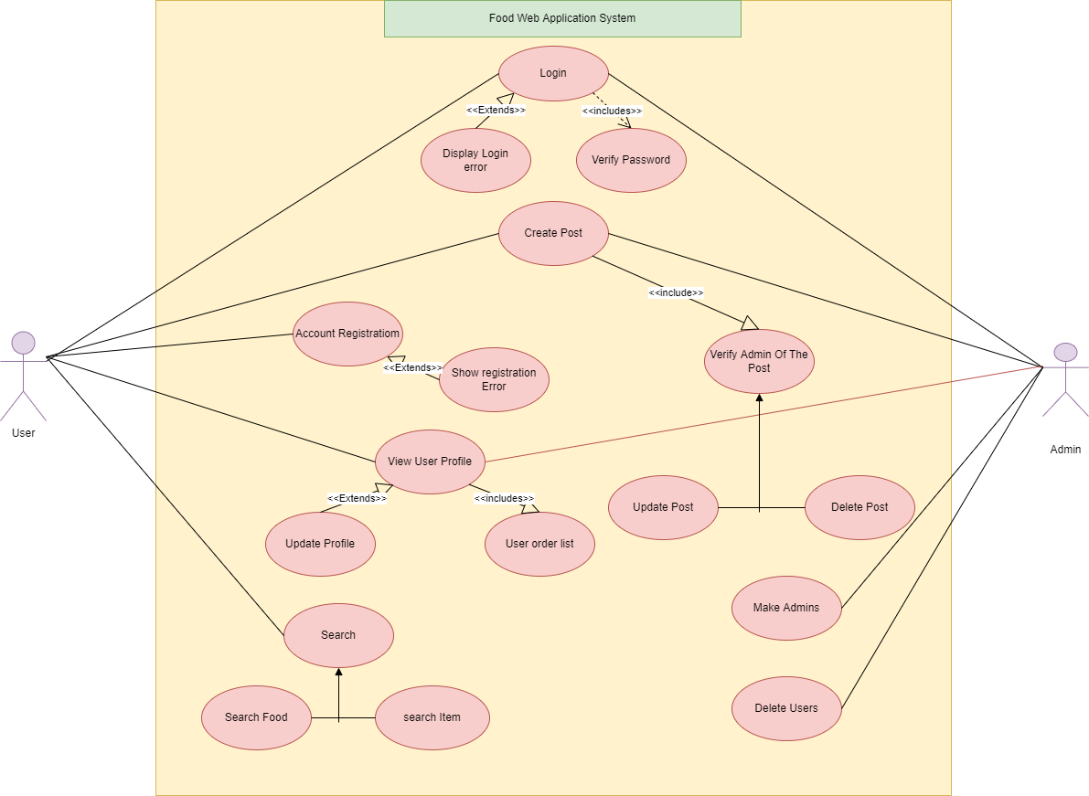

**Figure: 1**

**User Module Use Case Diagram:**

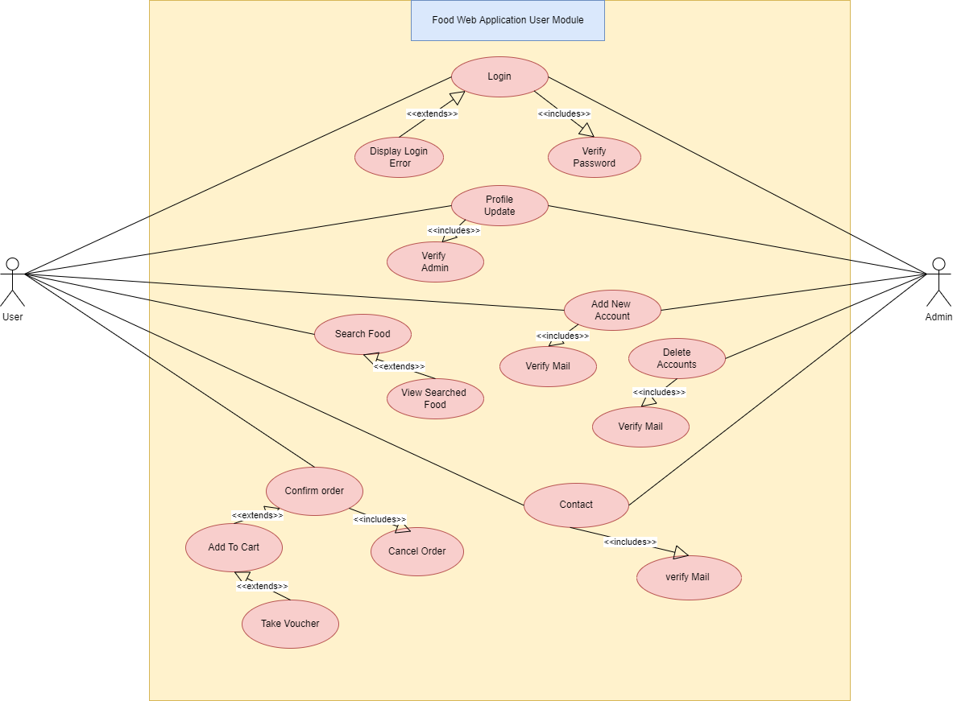

**Figure: 2**

**Class Diagram:**

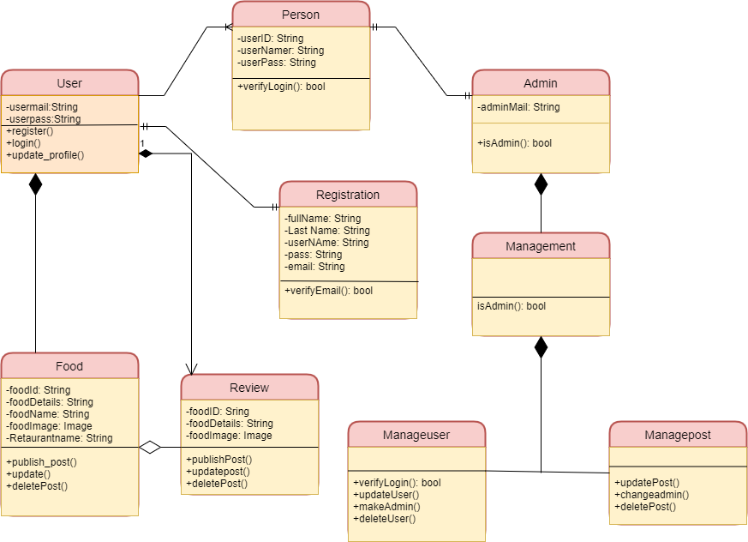

**Figure: 3**

**Sequence Diagram:**

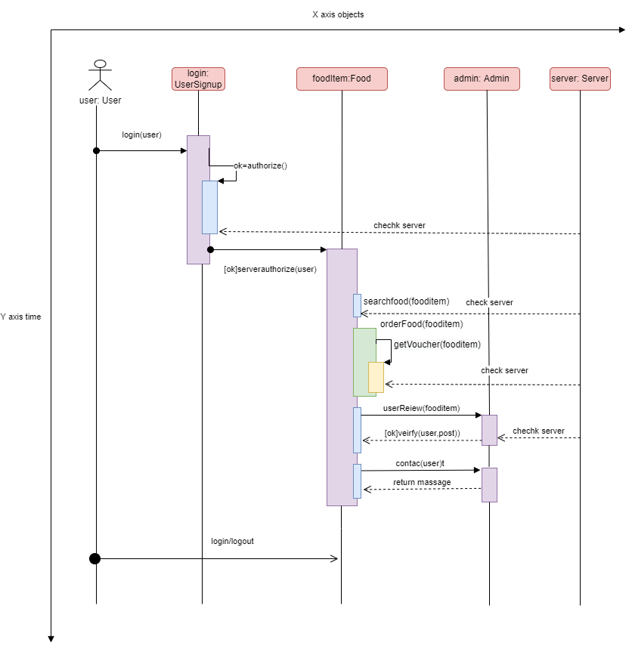

**Figure 4**

**Activity Diagram: (Profile and Update)**

**SWIMLINE**

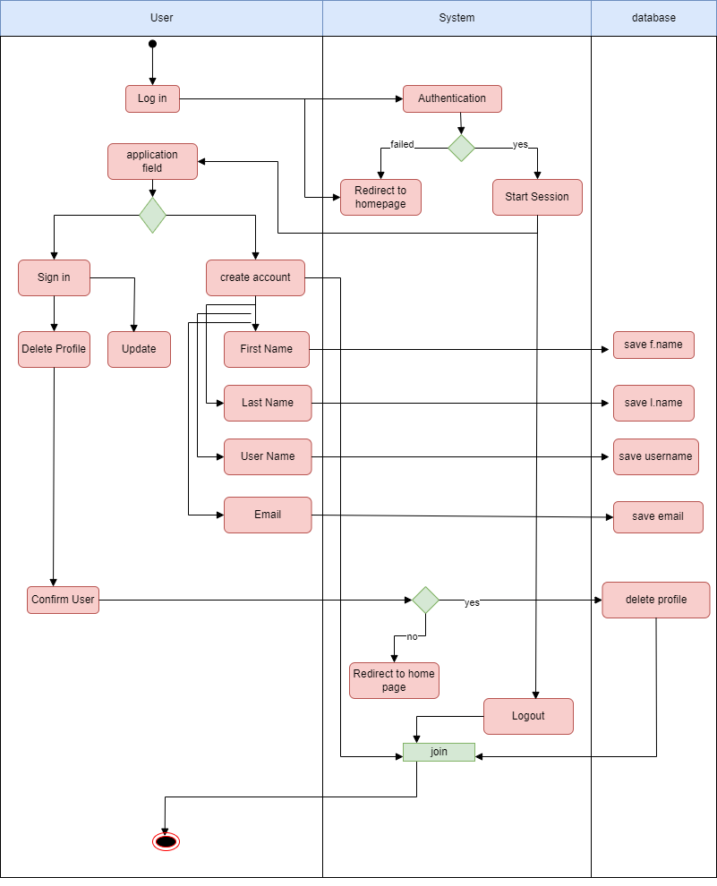

**Figure: 5**

**Activity Diagram: (Food Web Application)**

**SWIMLINE**

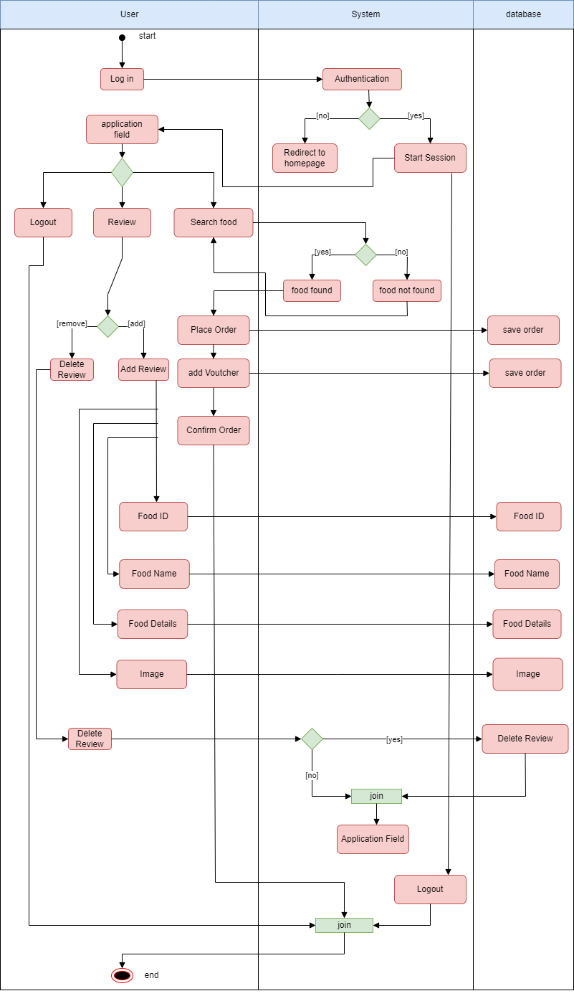

**Figure: 6**

**ER Diagram:**

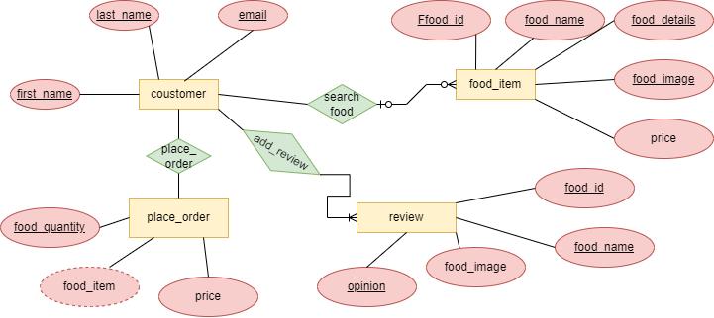

**Figure: 7**

**GUI SS**

**Landing Page**

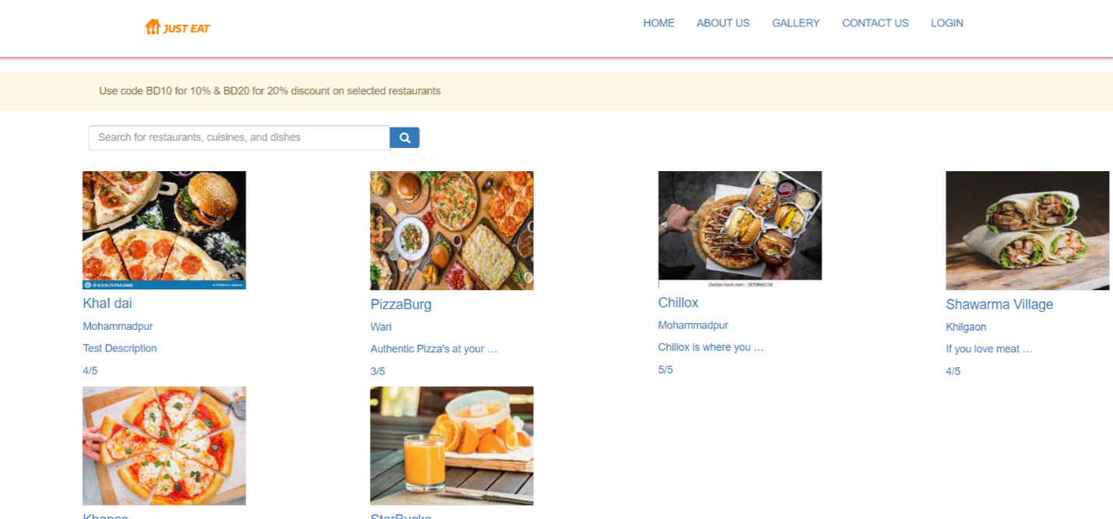

**Sign Up Page**



**Sign in Page**

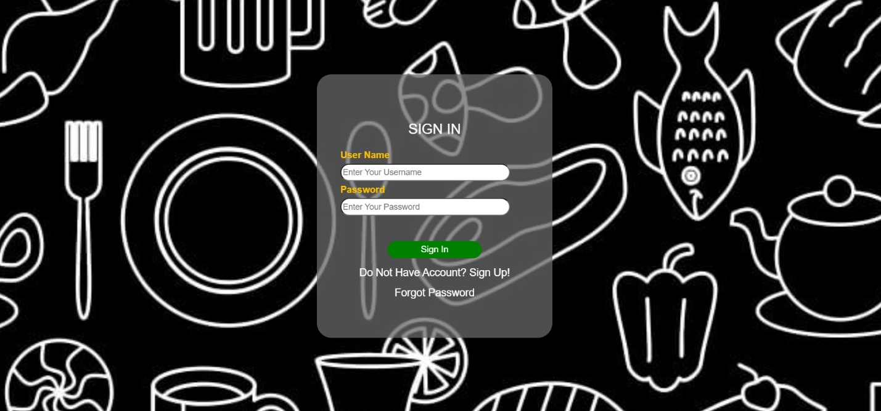

**Forgot Password**



**Password Reset**

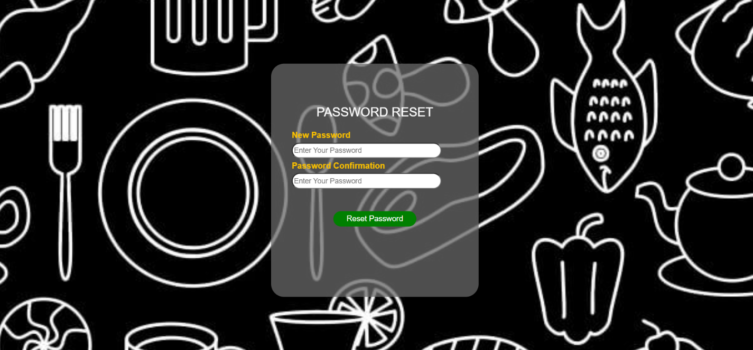

**About Us Page**

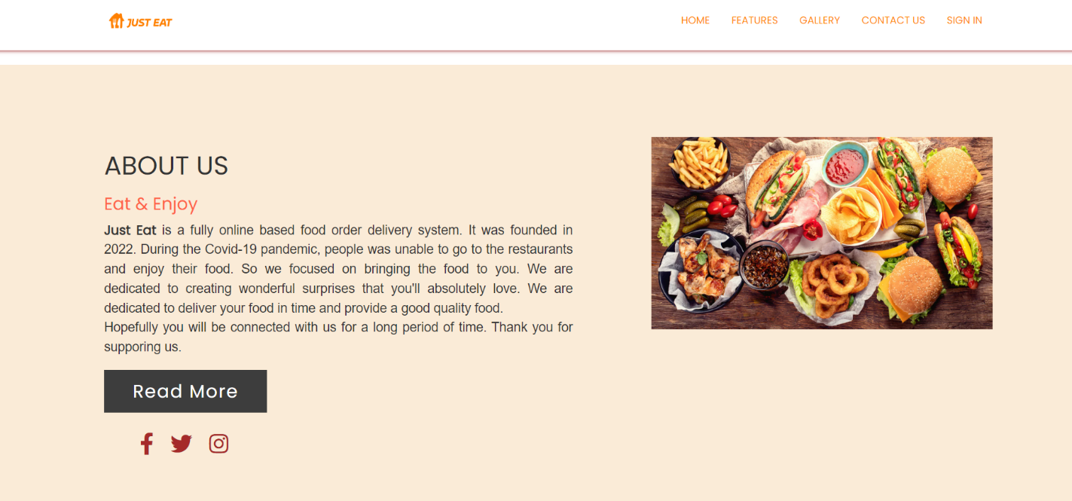

**Contact Us Page**

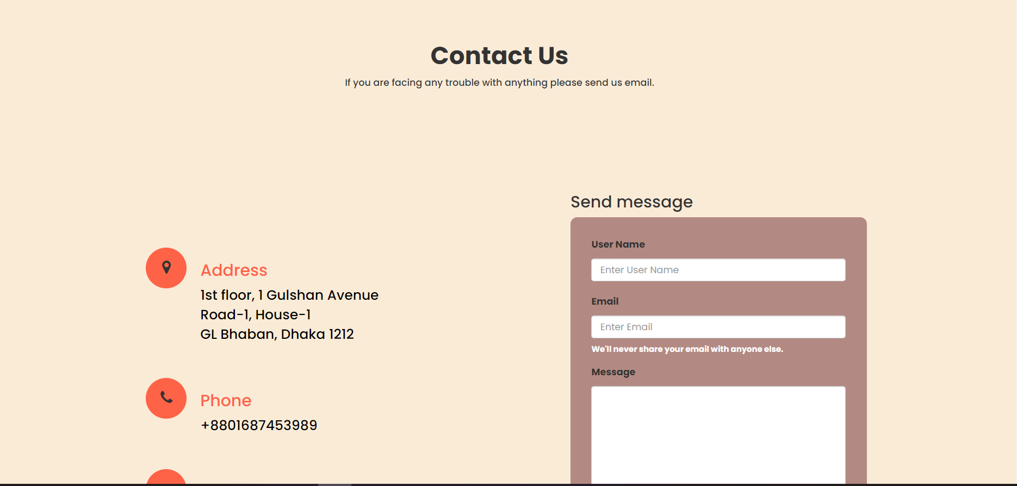

**Landing Page after signing in**

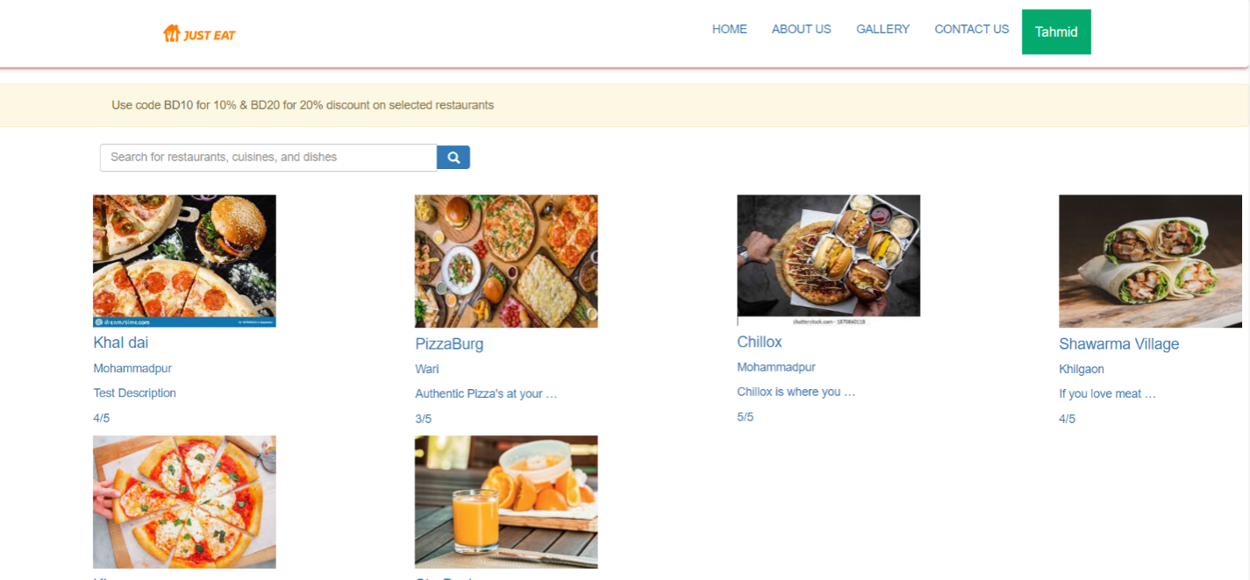

**Profile Dropdown Menu**

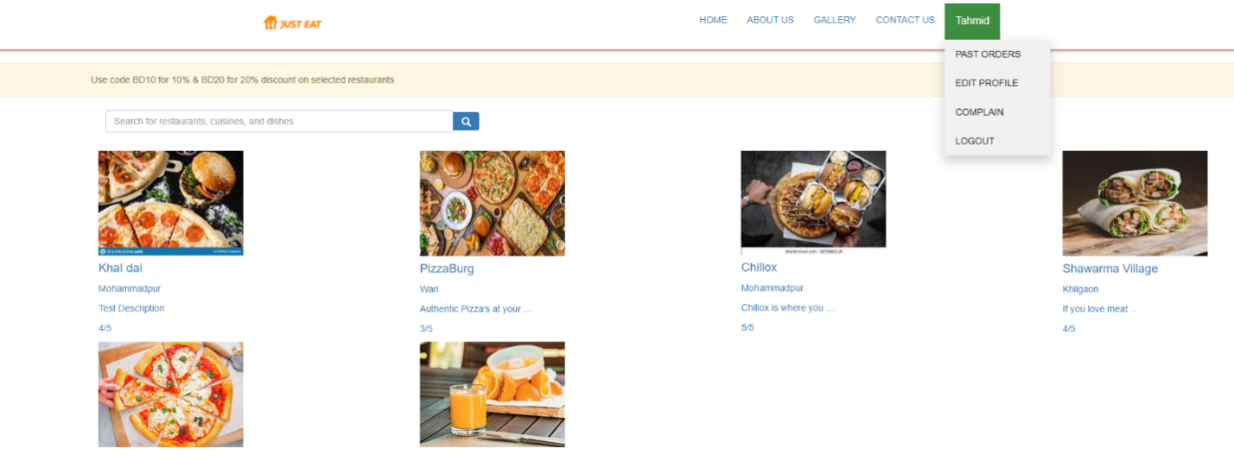

**Edit Profile Page**

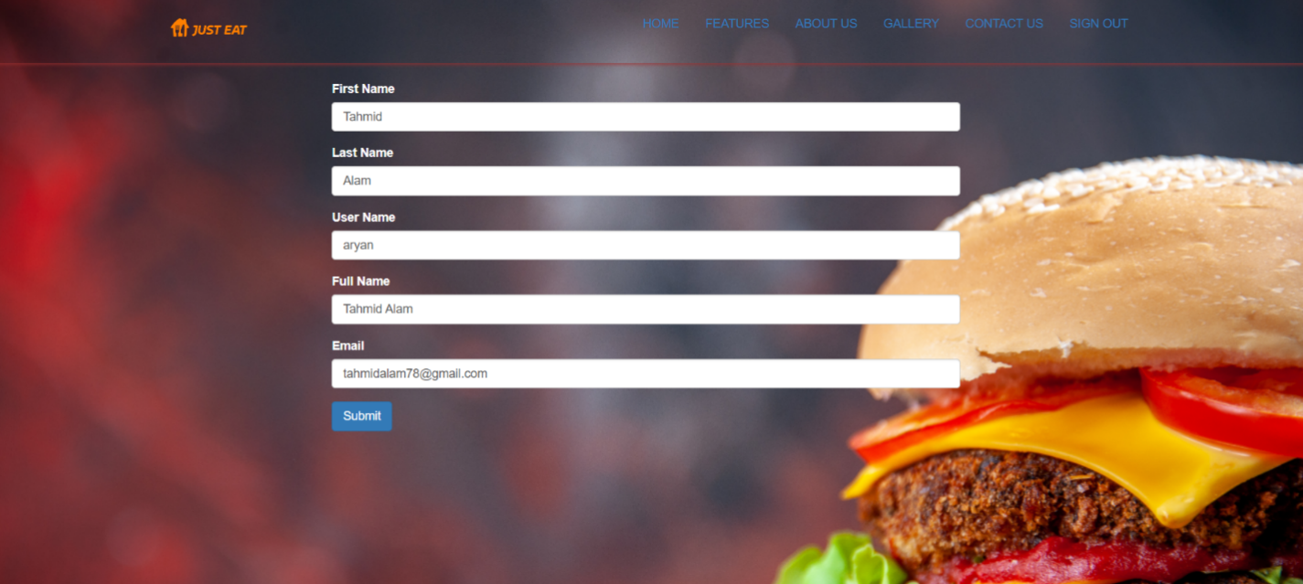

**Past Order Page**

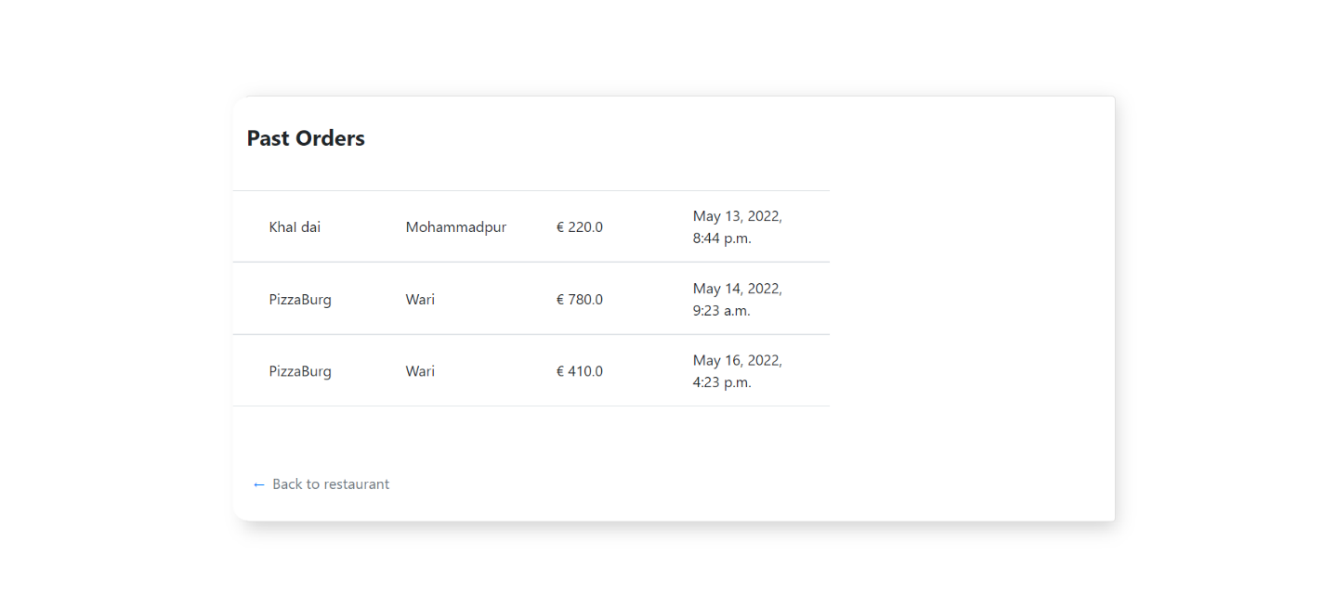

**Checkout page**

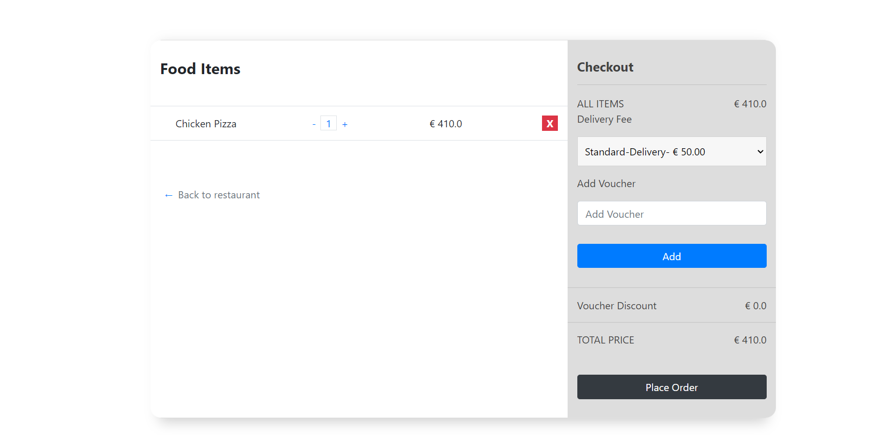

**Order Complete Page**

